**Practical 8:**

**Managing security groups and policies**

1. List and View Current Security Groups: Text

   Description automatically generatedText

   Description automatically generated
2. Create a security group:
   1. Ensure your system variables are set for the user and project for which you are creating security group rules.
   2. Add the new security group, as follows: 
   3. Add a new group rule, as follows: 
   4. View all rules for the new security group, as follows: Text

      Description automatically generated with medium confidence
3. Delete a security group:
   1. Ensure your system variables are set for the user and project for which you are deleting a security group.To enable a disabled user account
   2. Delete the new security group, as follows: 
4. Create security group rules for a cluster of instances:
   1. Make sure to set the system variables for the user and project for which you are creating a security group rule.
   2. Add a source group, as follows: Text

      Description automatically generated
5. Create and manage security group rules
   1. To list the rules for a security group, run the following command: 
   2. To allow SSH access to the instances, choose one of the following options:
      1. Allow access from all IP address, specified as IP subnet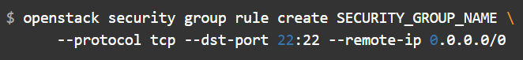
      2. Allow access only from IP address from other security groups to access the specified port: 
   3. To allow pinging of the instances, choose one of the following options:
      1. Allow pinging from all IP addresses, specified as IP subnet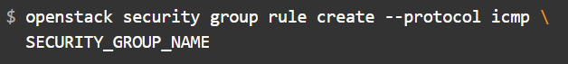
      2. Allow only members of other security groups to ping instancesText

         Description automatically generated
   4. To allow access through a UDP port, such as allowing to a DNS server that runs on a VM, choose one of the following options:
      1. Allow UDP access from IP address specidief as IP subnet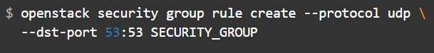
      2. Allow only IP addresses from other security groups to access the specified port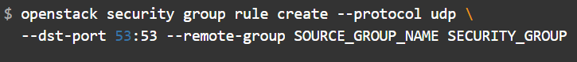
6. Delete a security group rule
   1. To delete a security group rule, specify the ID of the ruleText

      Description automatically generated